BACHU TEJASWINI
2303A54057 B-48
LAB 4
Assignment Number 3.3: Advanced Prompt Engineering – Zero-shot, One-shot, and Few-shot
Techniques
TASK1: Zero-Shot Prompting – Leap Year Check Scenario
PROMPT: generate a python code that takes year as an input and return whether it is leap year or not
EXPLANATION: A year is a leap year if it is divisible by 4 and not divisible by 100.
However, if the year is divisible by 400, it is a leap year.
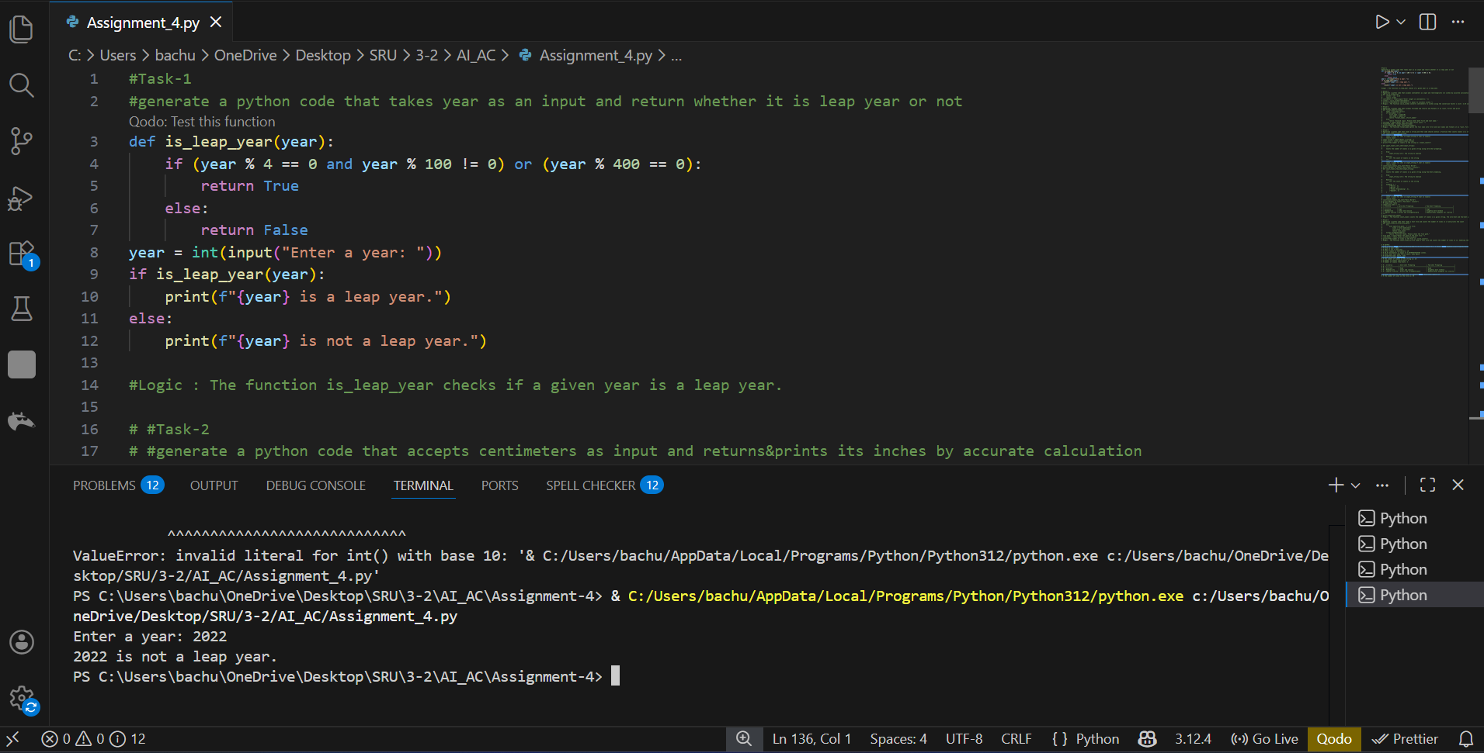
TASK2: One-Shot Prompting centimeters to Inches Conversion Scenario
PROMPT: Generate a python code that accepts centimeters as input and returns&prints its inches by accurate calculation
EXPLANATION: To convert centimeters to inches, divide the centimeter value by 2.54.
This is because 1 inch is equal to 2.54 centimeters.
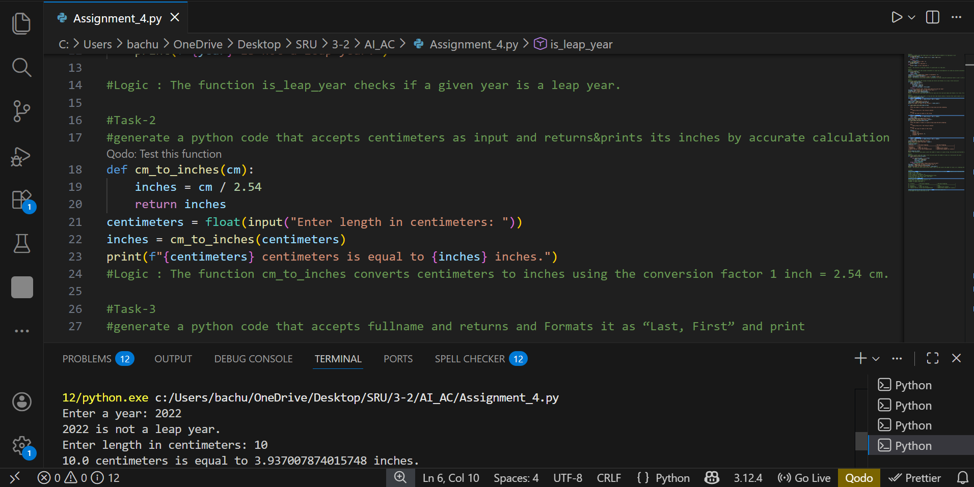
TASK3: Few-Shot Prompting – Name Formatting Scenario
PROMPT:generate a python code that accepts fullname and returns and Formats it as “Last, First” and print
EXPLANATION: The function takes a full name as input in the format First Last.
It splits the name into first and last parts and then rearranges them as Last, First.
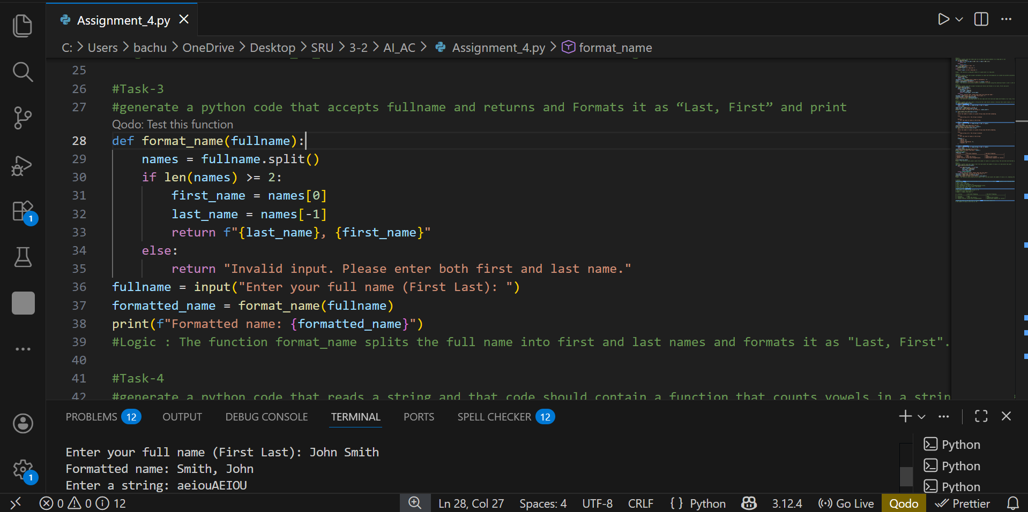
TASK4: Comparative Analysis – Zero-Shot vs Few-Shot Scenario
PROMPT: generate a python code that reads a string and that code should contain a function that counts vowels in a string using zero-shot prompting,few-shot prompting
EXPLANATION: This function directly checks each character in the string.If the character is a vowel (uppercase or lowercase), it increments the count.
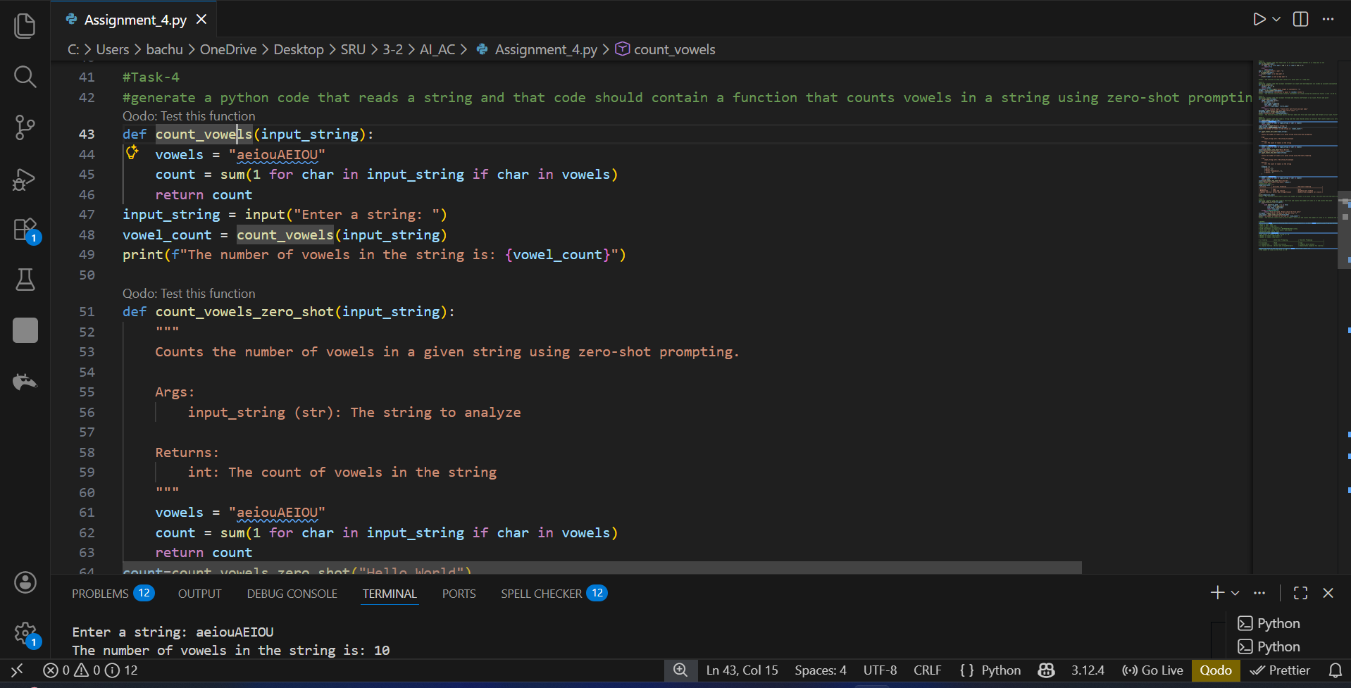
TASK5: Few-Shot Prompting – File Handling Scenario
PROMPT:generate a python code that reads a text file and counts the number of lines in it and prints the count
EXPLANATION: The program opens a text file in read mode.
It counts the total number of lines in the file and prints the count.
